

Programme Name: **BCS**

Course Code: **MPU3432**

Course Name: **Badminton**

Assignment **: First**

Date of Submission**: 6/11/2020**

**Submitted By: Submitted To:**

Student Name: **Dipesh Tha Shrestha** Name: **Manish Sir**

Semester: **Second**

Intake:**2019**

1. **Introduction of badminton, history, court measurement, equipments required for the game, category and scores (include pictures as well).**

***Answer***

**Badminton** is officially the fastest of all racket sports. Players can hit the shuttlecock at speeds of up to 180mph (288kph) toward their opponent. But, it is not just all about speed; a player can expect to run up to four miles (6.4km) around the court during a match whilst having the agility to maintain energy-busting rallies.

**Badminton** is a racquet sport played using racquets to hit a shuttlecock across a net. Although it may be played with larger teams, the most common forms of the game are "singles" (with one player per side) and "doubles" (with two players per side). Badminton is often played as a casual outdoor activity in a yard or on a beach; formal games are played on a rectangular indoor court. Points are scored by striking the shuttlecock with the racquet and landing it within the opposing side's half of the court.

Each side may only strike the shuttlecock once before it passes over the net. Play ends once the shuttlecock has struck the floor or if a fault has been called by the umpire, service judge, or (in their absence) the opposing side.

The shuttlecock is a feathered or (in informal matches) plastic projectile which flies differently from the balls used in many other sports. In particular, the feathers create much higher drag, causing the shuttlecock to decelerate more rapidly. Shuttlecocks also have a high top speed compared to the balls in other racquet sports. The flight of the shuttlecock gives the sport its distinctive nature.

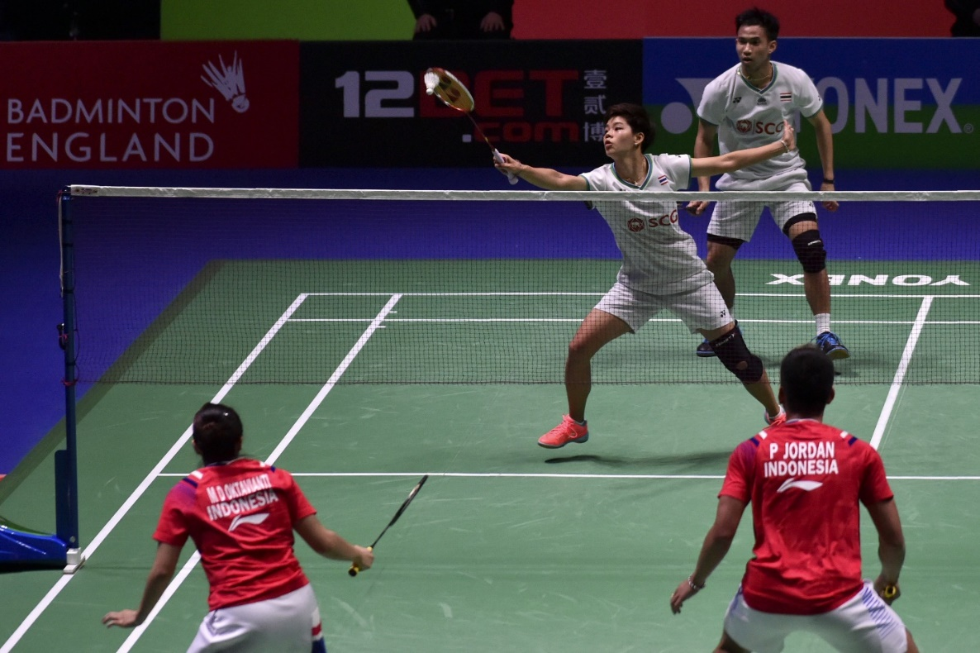

**History of badminton**

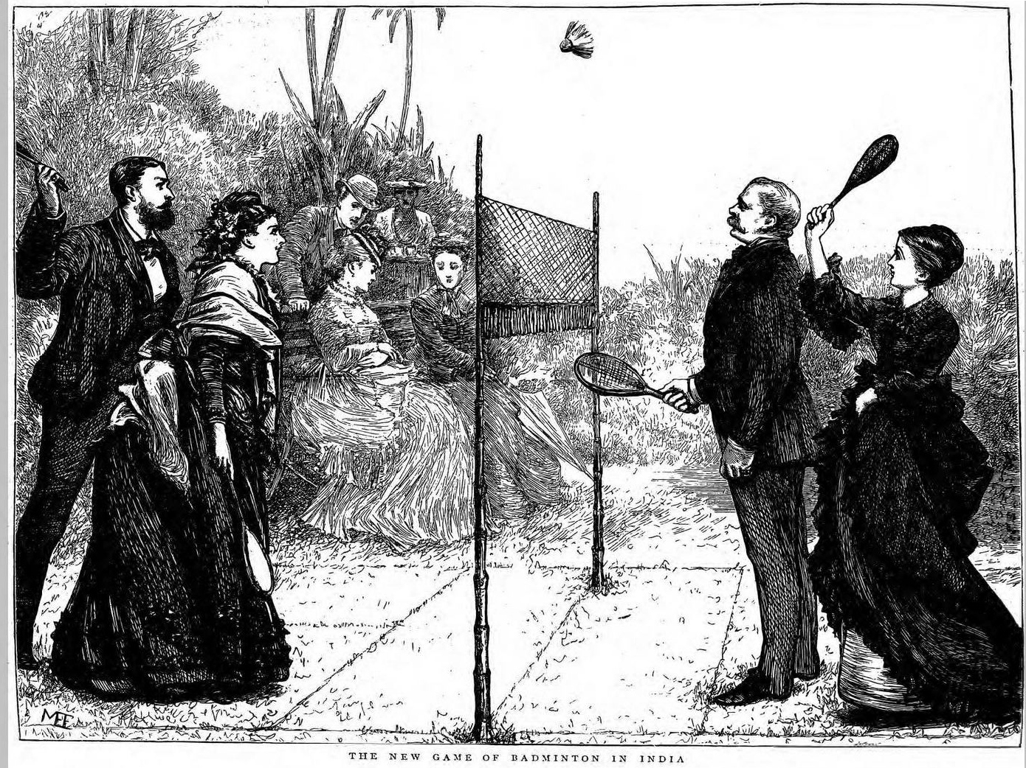

Badminton has its origins in ancient civilisations in Europe and Asia.  The ancient game known as battledore (bat or paddle) and shuttlecock probably originated more than 2000 years ago.

In the 1600s battledore and shuttlecock was an upper class pastime in England and many European countries. Battledore and shuttlecock was simply two people hitting a shuttlecock backwards and forwards with a simple bat as many times as they could without allowing it to hit the ground.

Modern badminton can be traced to mid-19th century British India. It was created by British military officers stationed there.  A net was added to the traditional English game of  battledore and shuttlecock. As it was popular in the British garrison town of Poona, the game came to be known as "Poona" or "*Poonai"* Initially, woollen balls were preferred by the upper classes in windy or wet conditions, but ultimately shuttlecocks took over the role of a "ball." This game was taken by retired officers who got back to England. It was introduced as a game for the guests of the Duke of Beaufort at his stately home 'Badminton' in Gloucestershire, England where it became popular. Hence, the origin of the name "Badminton."

In March 1898, the first Open Tournament was held at Guildford and the first 'All England' Championships were held the following year.

The International Badminton Federation was formed in 1934 with nine founder members,  England, Wales, Ireland, Scotland, Denmark, Holland, Canada, New Zealand and France.  India joined as an affiliate in 1936.

The first major IBF tournament was the Thomas Cup (world men's team championships) in 1948. Since then, the number of world events has increased with the addition of the Uber Cup (women's team), World Championships (individual events), Sudirman Cup (mixed team), World Junior Championships and the World Grand Prix Finals.

Badminton is a relatively new Olympic sport. It was a demonstration sport at the  1972 Munich Olympics. Badminton eventually became an Olympic sport in Barcelona in 1992. Only the singles and doubles were introduced for the first time in the Olympic Games. Mixed doubles was included in the 1996 Atlanta Olympic Games and badminton is the only sport that has mixed doubles event in the Olympics.

Only five countries have won gold medals at the Olympics since badminton was introduced in 1992 -  China, Indonesia and Korea, England and Denmark.

Susi Susanti from Indonesia won the women's singles in Barcelona, becoming Indonesia's first medallist after forty years participating in the Olympics. Ironically, Susi's future husband, Alan Budi Kusama won Indonesia's second gold medal in the men's singles.

**Court Measurement**

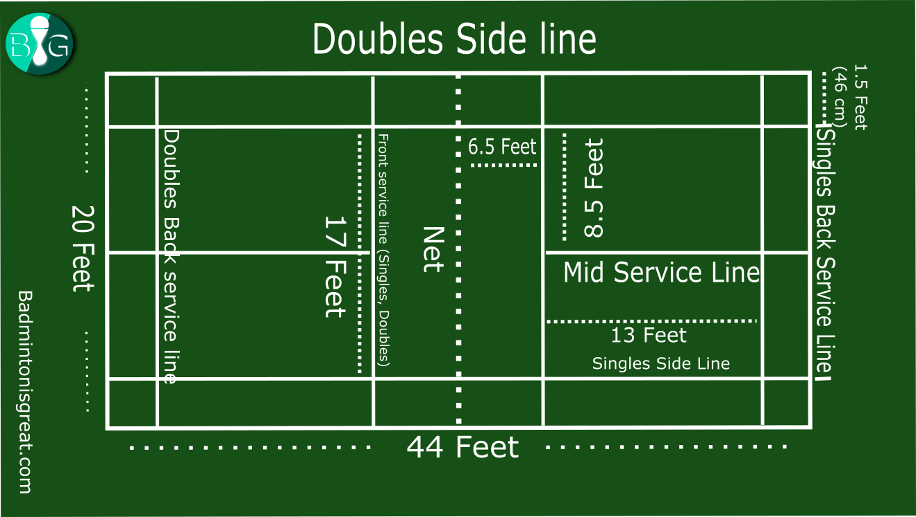

The court is rectangular and divided into halves by a net. Courts are usually marked for both singles and doubles play, although badminton rules permit a court to be marked for singles only. The doubles court is wider than the singles court, but both are of the same length. The exception, which often causes confusion to newer players, is that the doubles court has a shorter serve-length dimension.

The full width of the court is 6.1 metres (20 ft), and in singles this width is reduced to 5.18 metres (17 ft). The full length of the court is 13.4 metres (44 ft). The service courts are marked by a centre line dividing the width of the court, by a short service line at a distance of 1.98 metres (6 ft 6 inch) from the net, and by the outer side and back boundaries. In doubles, the service court is also marked by a long service line, which is 0.76 metres (2 ft 6 inch) from the back boundary.

The net is 1.55 metres (5 ft 1 inch) high at the edges and 1.524 metres (5 ft) high in the centre. The net posts are placed over the doubles sidelines, even when singles is played.

The minimum height for the ceiling above the court is not mentioned in the Laws of Badminton. Nonetheless, a badminton court will not be suitable if the ceiling is likely to be hit on a high serve.

**Equipment**

Equipment

[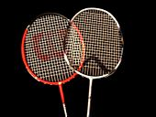](https://en.wikipedia.org/wiki/File:Heads_of_badminton_raquets.jpg)

Badminton [racquets](https://en.wikipedia.org/wiki/Racquet)

Badminton rules restrict the design and size of racquets and shuttlecocks.

**Racquets**

Badminton [racquets](https://en.wikipedia.org/wiki/Racket_(sports_equipment)) are lightweight, with top quality racquets weighing between 70 and 95 grams (2.5 and 3.4 ounces) not including grip or strings. They are composed of many different materials ranging from [carbon fibre composite](https://en.wikipedia.org/wiki/Carbon_fiber_composite) ([graphite reinforced plastic](https://en.wikipedia.org/wiki/Graphite_reinforced_plastic)) to solid steel, which may be augmented by a variety of materials. [Carbon fibre](https://en.wikipedia.org/wiki/Carbon_fibre) has an excellent strength to weight ratio, is stiff, and gives excellent [kinetic energy](https://en.wikipedia.org/wiki/Kinetic_energy) transfer. Before the adoption of carbon fibre composite, racquets were made of light metals such as aluminium. Earlier still, racquets were made of wood. Cheap racquets are still often made of metals such as steel, but wooden racquets are no longer manufactured for the ordinary market, because of their excessive mass and cost. Nowadays, nanomaterials such as [carbon nanotubes](https://en.wikipedia.org/wiki/Carbon_nanotubes) and [fullerene](https://en.wikipedia.org/wiki/Fullerene) are added to racquets giving them greater durability.

There is a wide variety of racquet designs, although the laws limit the racquet size and shape. Different racquets have playing characteristics that appeal to different players. The traditional oval head shape is still available, but an [isometric](https://en.wiktionary.org/wiki/isometric) head shape is increasingly common in new racquets.

**Strings**

Badminton strings for racquets are thin, high performing strings with thicknesses ranging from about 0.62 to 0.73 mm. Thicker strings are more durable, but many players prefer the feel of thinner strings. String tension is normally in the range of 80 to 160 [N](https://en.wikipedia.org/wiki/Newton_(unit)) (18 to 36 [lbf](https://en.wikipedia.org/wiki/Pound-force" \o "Pound-force)). Recreational players generally string at lower tensions than professionals, typically between 80 and 110 N (18 and 25 lbf). Professionals string between about 110 and 160 N (25 and 36 lbf). Some string manufacturers measure the thickness of their strings under tension so they are actually thicker than specified when slack. Ashaway Micropower is actually 0.7mm but Yonex BG-66 is about 0.72mm.

It is often argued that high string tensions improve control, whereas low string tensions increase power.[[16]](https://en.wikipedia.org/wiki/Badminton#cite_note-19) The arguments for this generally rely on crude mechanical reasoning, such as claiming that a lower tension string bed is more bouncy and therefore provides more power. This is, in fact, incorrect, for a higher string tension can cause the shuttle to slide off the racquet and hence make it harder to hit a shot accurately. An alternative view suggests that the optimum tension for power depends on the player:[[14]](https://en.wikipedia.org/wiki/Badminton#cite_note-oqgysc-17) the faster and more accurately a player can swing their racquet, the higher the tension for maximum power. Neither view has been subjected to a rigorous mechanical analysis, nor is there clear evidence in favour of one or the other. The most effective way for a player to find a good string tension is to experiment.

[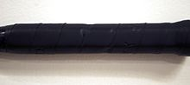](https://en.wikipedia.org/wiki/File:Badminton_Undergrip_Flat.jpg)

Badminton Undergrip Flat

**Grip**

The choice of grip allows a player to increase the thickness of their racquet handle and choose a comfortable surface to hold. A player may build up the handle with one or several grips before applying the final layer.

Players may choose between a variety of grip materials. The most common choices are [PU](https://en.wikipedia.org/wiki/Polyurethane) synthetic grips or towelling grips. Grip choice is a matter of personal preference. Players often find that sweat becomes a problem; in this case, a drying agent may be applied to the grip or hands, sweatbands may be used, the player may choose another grip material or change their grip more frequently.

There are two main types of grip: *replacement* grips and *overgrips*. Replacement grips are thicker and are often used to increase the size of the handle. Overgrips are thinner (less than 1 mm), and are often used as the final layer. Many players, however, prefer to use replacement grips as the final layer. Towelling grips are always replacement grips. Replacement grips have an adhesive backing, whereas overgrips have only a small patch of adhesive at the start of the tape and must be applied under tension; overgrips are more convenient for players who change grips frequently, because they may be removed more rapidly without damaging the underlying material.

**Shuttlecock**

[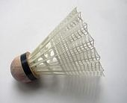](https://en.wikipedia.org/wiki/File:ShuttlecockPhoto.jpg)

A shuttlecock with a plastic skirt

[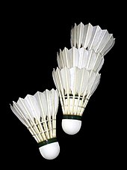](https://en.wikipedia.org/wiki/File:Shuttlecocks_Yonex_Aerosensa_20.jpg)

[Shuttlecocks](https://en.wikipedia.org/wiki/Shuttlecock) with feathers

*Main article:*[*Shuttlecock*](https://en.wikipedia.org/wiki/Shuttlecock)

A shuttlecock (often abbreviated to *shuttle*; also called a *birdie*) is a high-drag [projectile](https://en.wikipedia.org/wiki/Projectile), with an open [conical shape](https://en.wikipedia.org/wiki/Cone_(geometry)): the cone is formed from sixteen overlapping [feathers](https://en.wikipedia.org/wiki/Feathers) embedded into a rounded cork base. The [cork](https://en.wikipedia.org/wiki/Cork_(material)) is covered with thin [leather](https://en.wikipedia.org/wiki/Leather) or synthetic material. [Synthetic](https://en.wikipedia.org/wiki/Nylon_(material)) shuttles are often used by recreational players to reduce their costs as feathered shuttles break easily. These nylon shuttles may be constructed with either natural cork or synthetic foam base and a plastic skirt.

Badminton rules also provide for testing a shuttlecock for the correct speed:

**3.1**: To test a shuttlecock, hit a full underhand stroke which makes contact with the shuttlecock over the back boundary line. The shuttlecock shall be hit at an upward angle and in a direction parallel to the sidelines. **3.2**: A shuttlecock of the correct speed will land not less than 530 mm and not more than 990 mm short of the other back boundary line.

**Shoes**

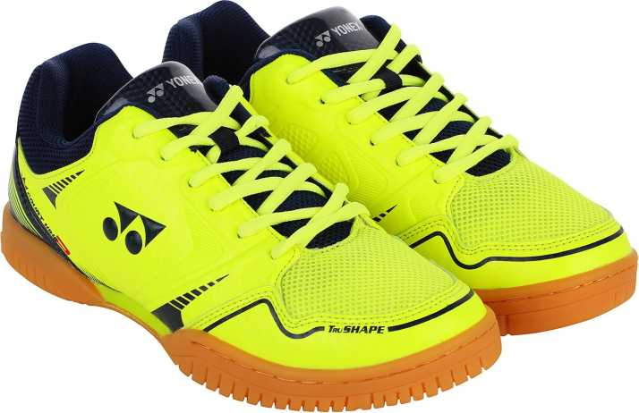

Badminton [shoes](https://en.wikipedia.org/wiki/Athletic_shoe) are lightweight with soles of [rubber](https://en.wikipedia.org/wiki/Rubber) or similar high-grip, non-marking materials.

Compared to running shoes, badminton shoes have little [lateral support](https://en.wikipedia.org/wiki/Support_(structure)). High levels of lateral support are useful for activities where lateral motion is undesirable and unexpected. Badminton, however, requires powerful lateral movements. A highly built-up lateral support will not be able to protect the foot in badminton; instead, it will encourage catastrophic collapse at the point where the shoe's support fails, and the player's ankles are not ready for the sudden loading, which can cause sprains. For this reason, players should choose badminton shoes rather than general trainers or running shoes, because proper badminton shoes will have a very thin sole, lower a person's centre of gravity, and therefore result in fewer injuries. Players should also ensure that they learn safe and proper footwork, with the knee and foot in alignment on all lunges. This is more than just a safety concern: proper footwork is also critical in order to move effectively around the court.

**Age categories**

Men & Women Singles and Doubles: 35+, 40+, 45+, 50+, 55+, 60+, 65+, 70+, 75+, 80+  
Mixed Doubles: 35+, 40+, 45+, 50+, 55+, 60+, 65+, 70+, 75+, 80+  
Mixed Teams Event: 35+, 40+, 45+, 50+, 55+, 60+, 65+, 70+, 75+, 80+

The age category you will compete in for Badminton will be determined as at 31 December of the year of the event. For example, if you are 39 during Games time but have turned 40 by 31 December, you would compete in the 40+ age category. The age of the youngest player on the team will determinate the team’s age category.

**Scoring**

*Main article:*[*Scoring system development of badminton*](https://en.wikipedia.org/wiki/Scoring_system_development_of_badminton)

Each game is played to 21 points, with players scoring a point whenever they win a rally regardless of whether they served (this differs from the old system where players could only win a point on their serve and each game was played to 15 points). A match is the best of three games.

If the score reaches 20-all, then the game continues until one side gains a two-point lead (such as 24–22), except when there is a tie at 29-all, in which the game goes to a golden point. Whoever scores this point will win.

At the start of a match, the shuttlecock is cast and the side towards which the shuttlecock is pointing serves first. Alternatively, a coin may be tossed, with the winners choosing whether to serve or receive first, or choosing which end of the court to occupy first, and their opponents making the leftover the remaining choice.

In subsequent games, the winners of the previous game serve first. Matches are best out of three: a player or pair must win two games (of 21 points each) to win the match. For the first rally of any doubles game, the serving pair may decide who serves and the receiving pair may decide who receives. The players change ends at the start of the second game; if the match reaches a third game, they change ends both at the start of the game and when the leading player's or pair's score reaches 11 points.